Chapter 3: Displaying and Summarizing Quantitative Data

Part II: Center, Spread, and Boxplot

**Earthquakes Example:**

Source: NOAA (National Oceanic and Atmospheric Administration.)

1. **Statistical Measurements using Data Analysis:**
2. Open the data file (Earthquakes 1987-2011.csv). In this file, there are four variables which are year, month, day, and magnitude.
3. Select the **Data** tab $⟹$**Data Analysis**.

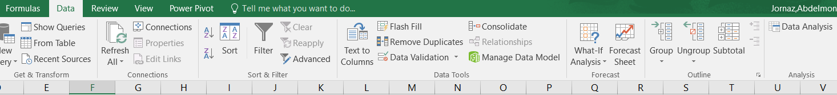

1. The **Data Analysis** dialogbox will appear, select **Descriptive Statistics** and click **OK**.

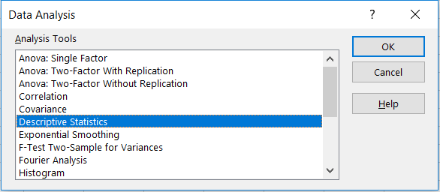

1. The **Descriptive Statistics** dialogbox will appear. Click on **Input Range** and select the variable. Click on **Output Range** and select any empty cell to present the results on it, then select **Summary Statistics** and click **OK**.

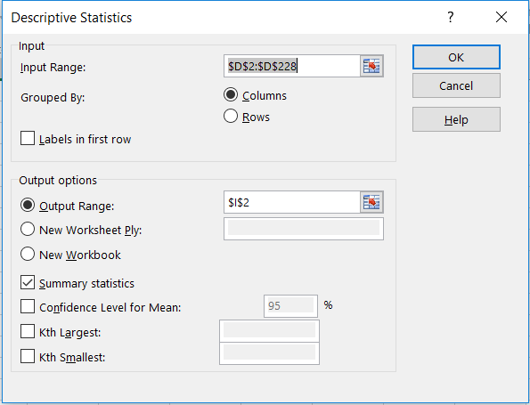

1. The results is

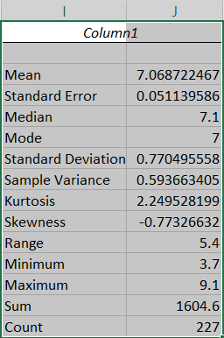

1. **Statistical Measurements using Formulas:**
2. Type the measurements names in one column and in the next column we add the formulas.
3. Select the **Formulas** tab $⟹$**More Function $⟹$ Statistical $⟹$** statistical measure.

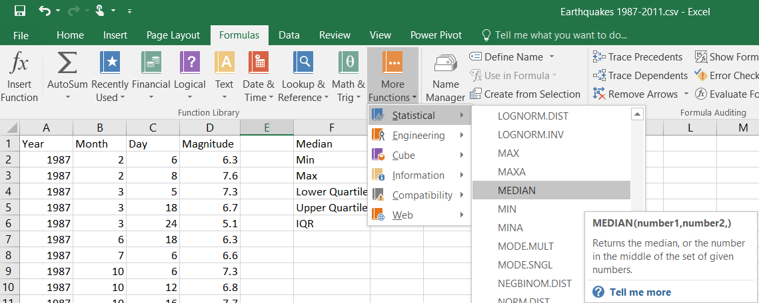

1. The **Function Arguments** box will appear, click on **Number 1** and select the data range, then click **OK**.

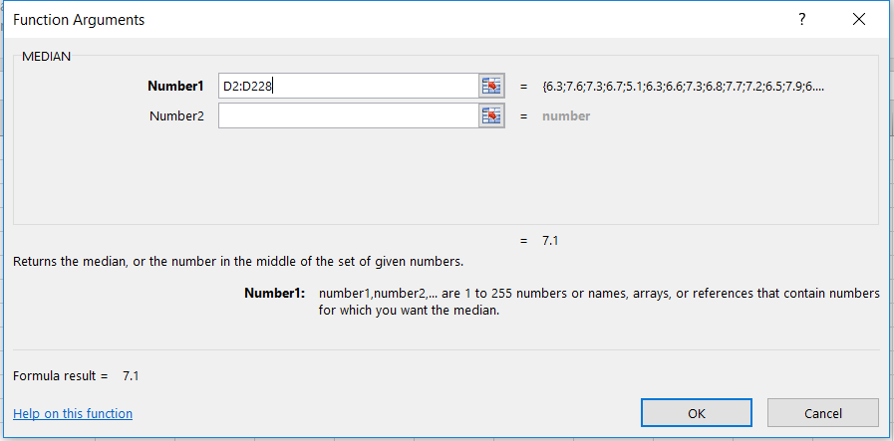

1. You may also just type the statistical measurements such as



1. Do so with the rest of the measurements

|  |  |
| --- | --- |
| Measurement | Formula |
| Median |  |
| Minimum |  |
| Maximum |  |
| Range |  |
| Lower Quartile |  |
| Upper Quartile |  |
| Interquartile Range |  |
| Mean (Average) |  |
| Variance |  |
| Standard Deviation |  |

1. Minimum:

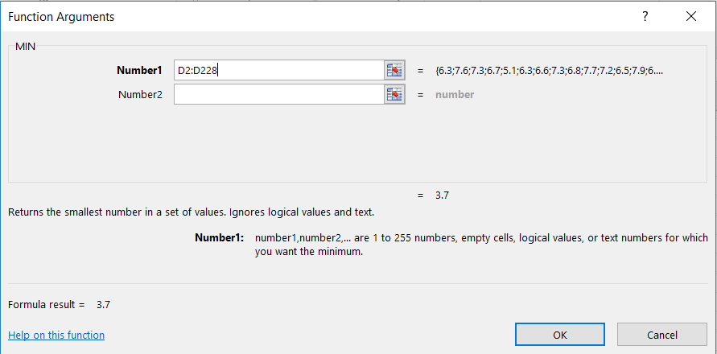

1. Maximum:

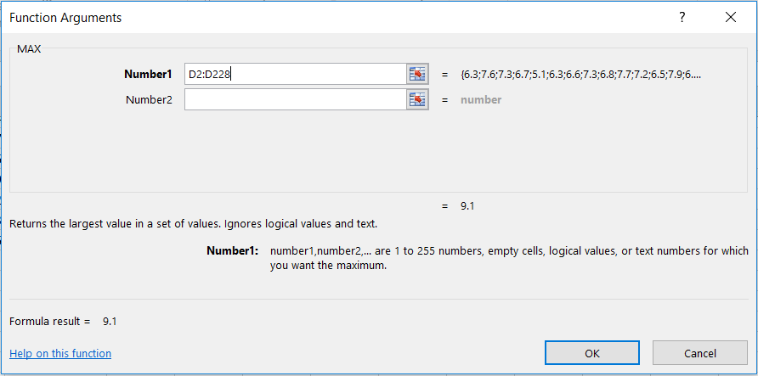

1. Range:

There is no formula for the range, so we just type “= maximum value – minimum value”.

1. Lower Quartile:

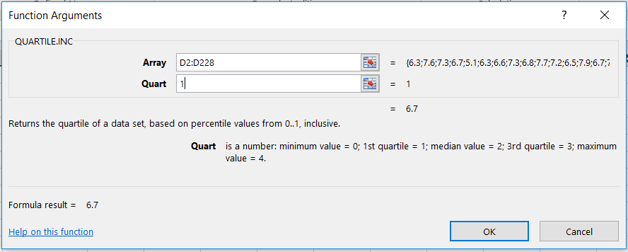

1. Upper Quartile:

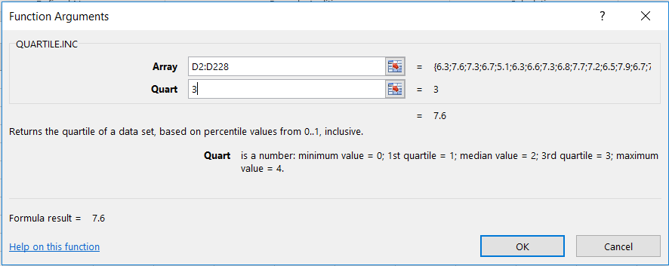

**Note:** for the quartiles, select the formula “QUARTILE.INC(array,quart)”. “INC” means inclusive which means that included the minimum and maximum value (all data set).

The other formula “QUARTILE.EXC(array,quart)”. “EXC” means exclusive which means that excluded the minimum and maximum value (not all data set).



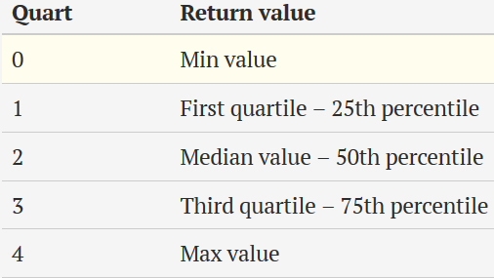

1. Interquartile Range:

There is no formula for the range, so we just type “= upper quartile value – lower quartile value”.

1. Mean:

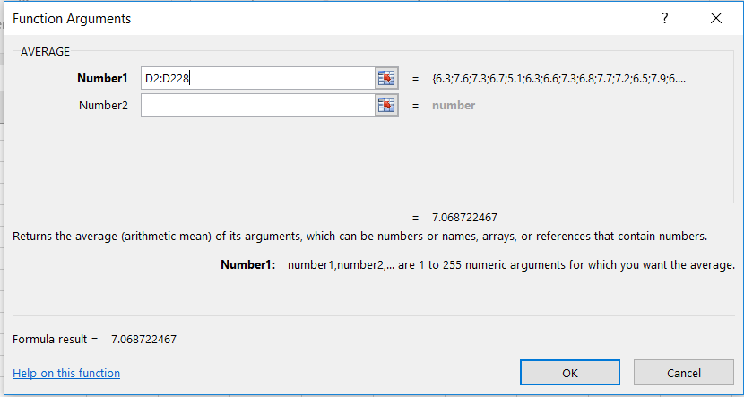

1. Variance:

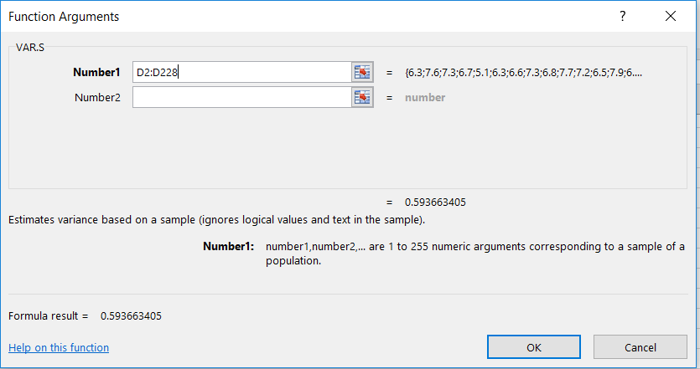

1. Standard Deviation:

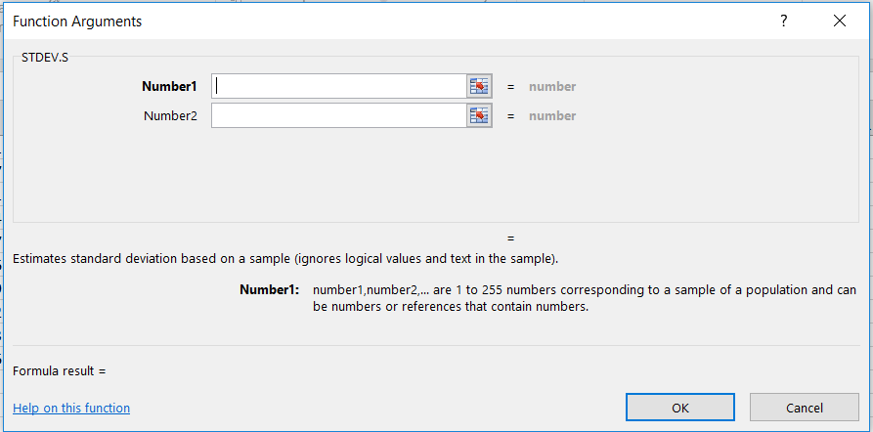

**Note:** for the variance and standard deviation, select the formulas “VAR.S(number1,)” and “STDEV.S(number1,)”. “S” means sample.

The other formulas “VAR.P(number1,)” and “STDEV.P(number1,)” are used for the population, and most of our examples are for the samples.

1. The result is

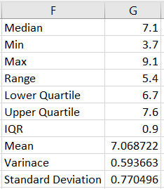

1. **Boxplot:**
2. Select the data set.
3. Select the **Insert** tab $⟹$ I**nsert Statistic Chart $⟹$ Box and Whiskers**.

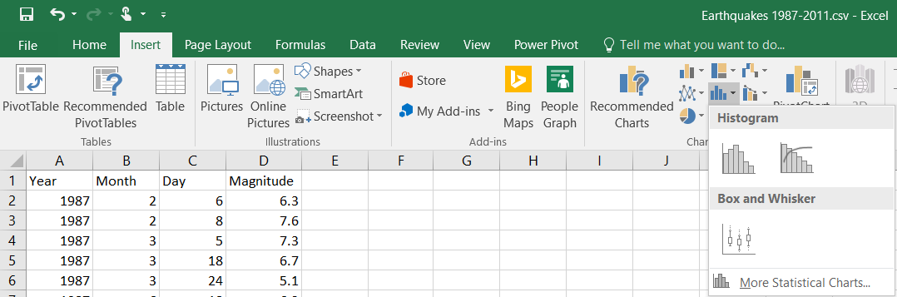

1. The result is

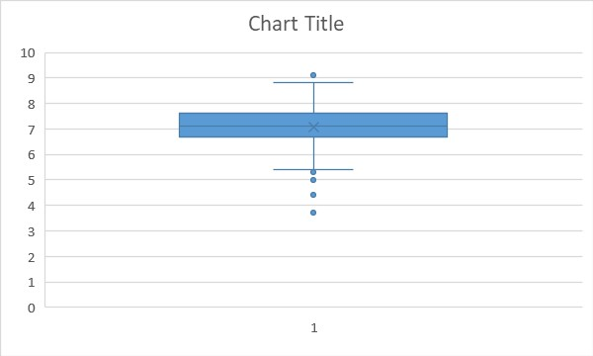

1. We can control the Y axis. Since the minimum is 3.7 and the maximum is 9.1 , so double click on the Y axis, the **Format Axis** dialog box will appear, then we replace the **Minimum** and **Maximum** values as we want.

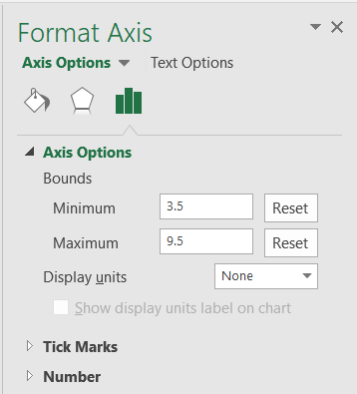

1. The result is

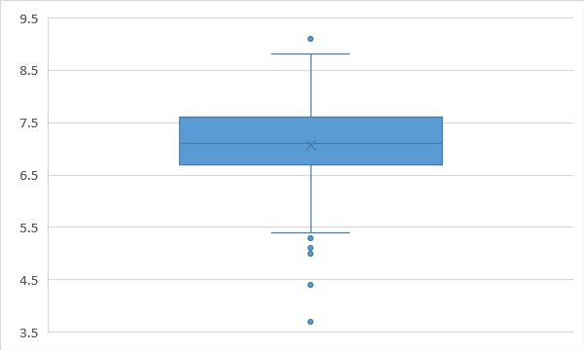

**Note:** we can set the graph title and Y axis label. See Chapter 2 – Part 2.